Task 1 – Install Required Tools
Anaconda / Miniconda installed
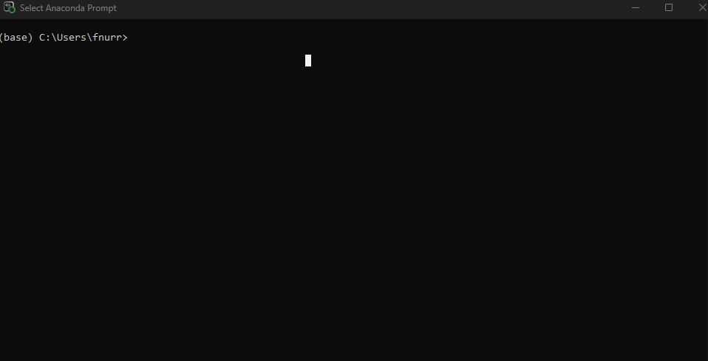
Pycharm interface
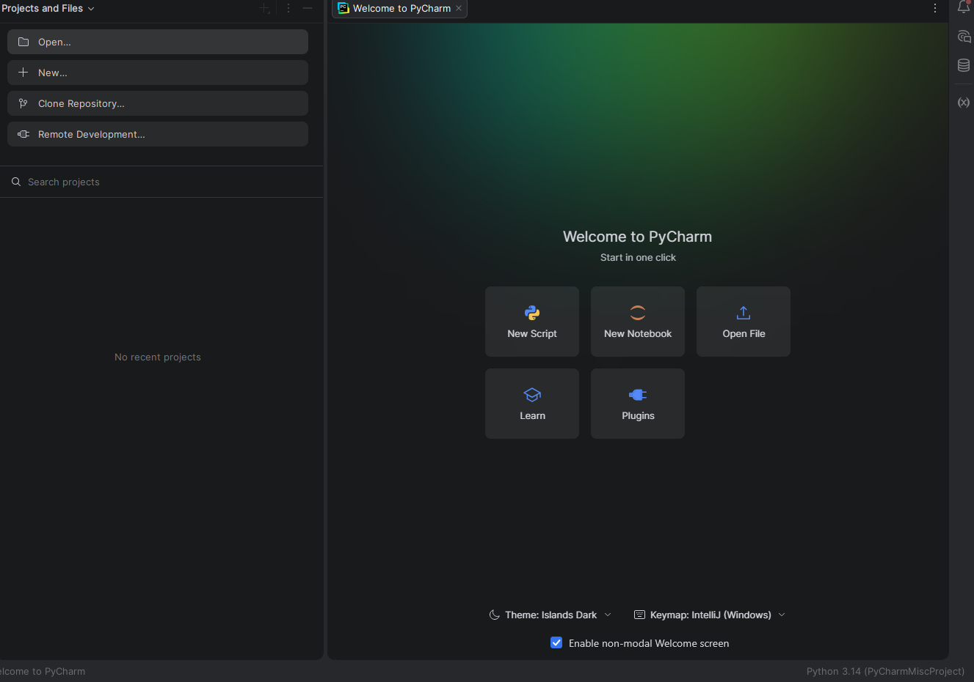
Git version
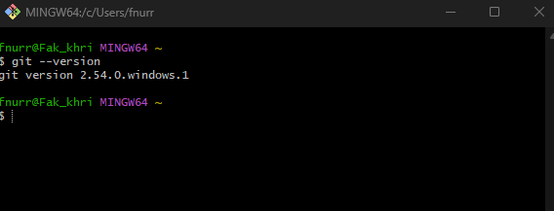

Task 2 – Create Python Environment
Activated environment
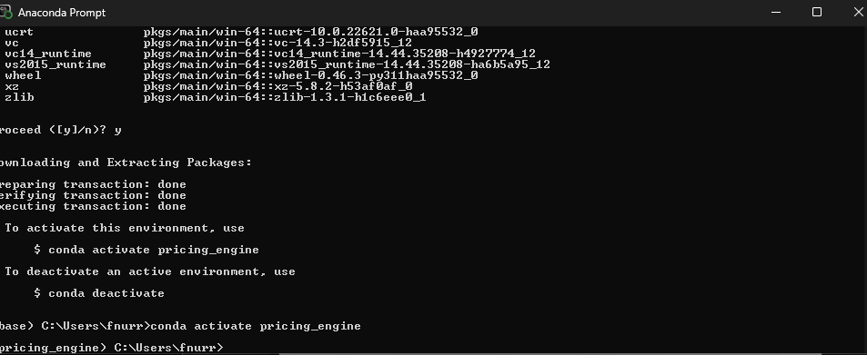
Python version
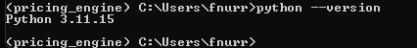

Task 3 – Install Requirements

Task 4 – Create GitHub Account & Repository
Github profile link
https://github.com/fnurrahmadi

Repository link
https://github.com/fnurrahmadi/pricing-engine-case-study

Task 5 – Connect Local Project to GitHub

